Appendix M. IT tools to be used
Need | Specific Tools | Why this tool
UI mockups and clickable prototype |   Figma | Fast wireframing and interactive prototypes for stakeholder review and UI validation.
Frontend (web UI) |   React + TypeScript | Component-based UI for dashboards and queues, with TypeScript for safer handling of complex workflow states.
UI styling |   Tailwind CSS | Utility-first styling for consistent layouts with minimal custom CSS.
Charts for dashboards |   Chart.js | Lightweight charting for operational dashboards (counts, queues, aging/time-in-stage).
Backend (API + business rules) |   Node.js + Express.js (REST API) | Minimal backend framework for building API endpoints and implementing routing and workflow rules.
Authentication | 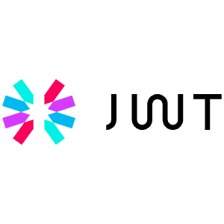  JWT (RFC 7519; internet standard) | Standard token format for stateless authentication between frontend and API.
Database | 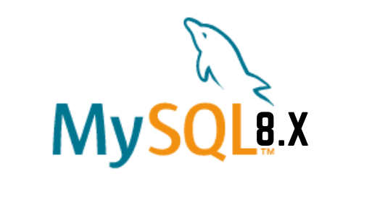  MySQL 8 (InnoDB) | Relational data model with foreign keys for lifecycle, milestones, tasks, and audit logs, enabling consistent reporting queries.
Schema migration and DB access | 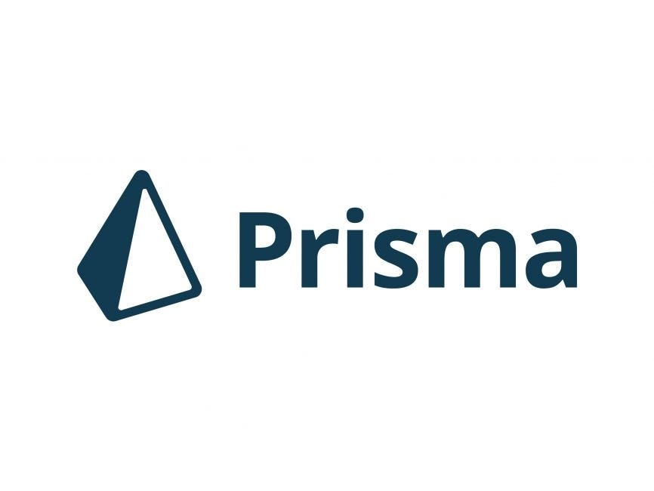  Prisma ORM (migrations + type-safe DB client) | One tool for repeatable schema migrations and type-safe database access, reducing manual SQL drift across sprints.
Project tracking and version control |   GitHub (Repo + Issues/Projects) | Source control and sprint tracking (issues, boards, basic backlog).
Diagrams | 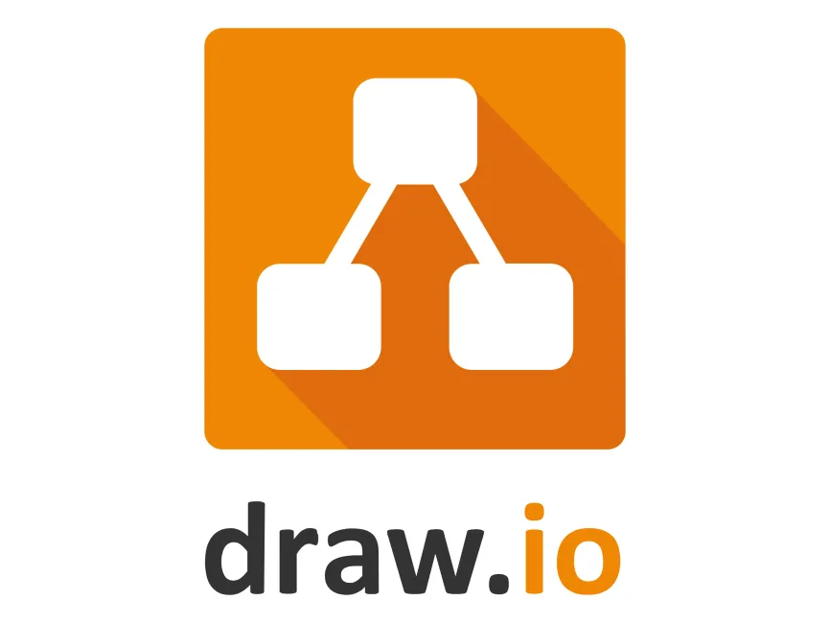  draw.io    dbdiagram.io | Process and architecture diagrams (BPMN, ERD, system diagrams) with a lightweight tool.
Domain and DNS | 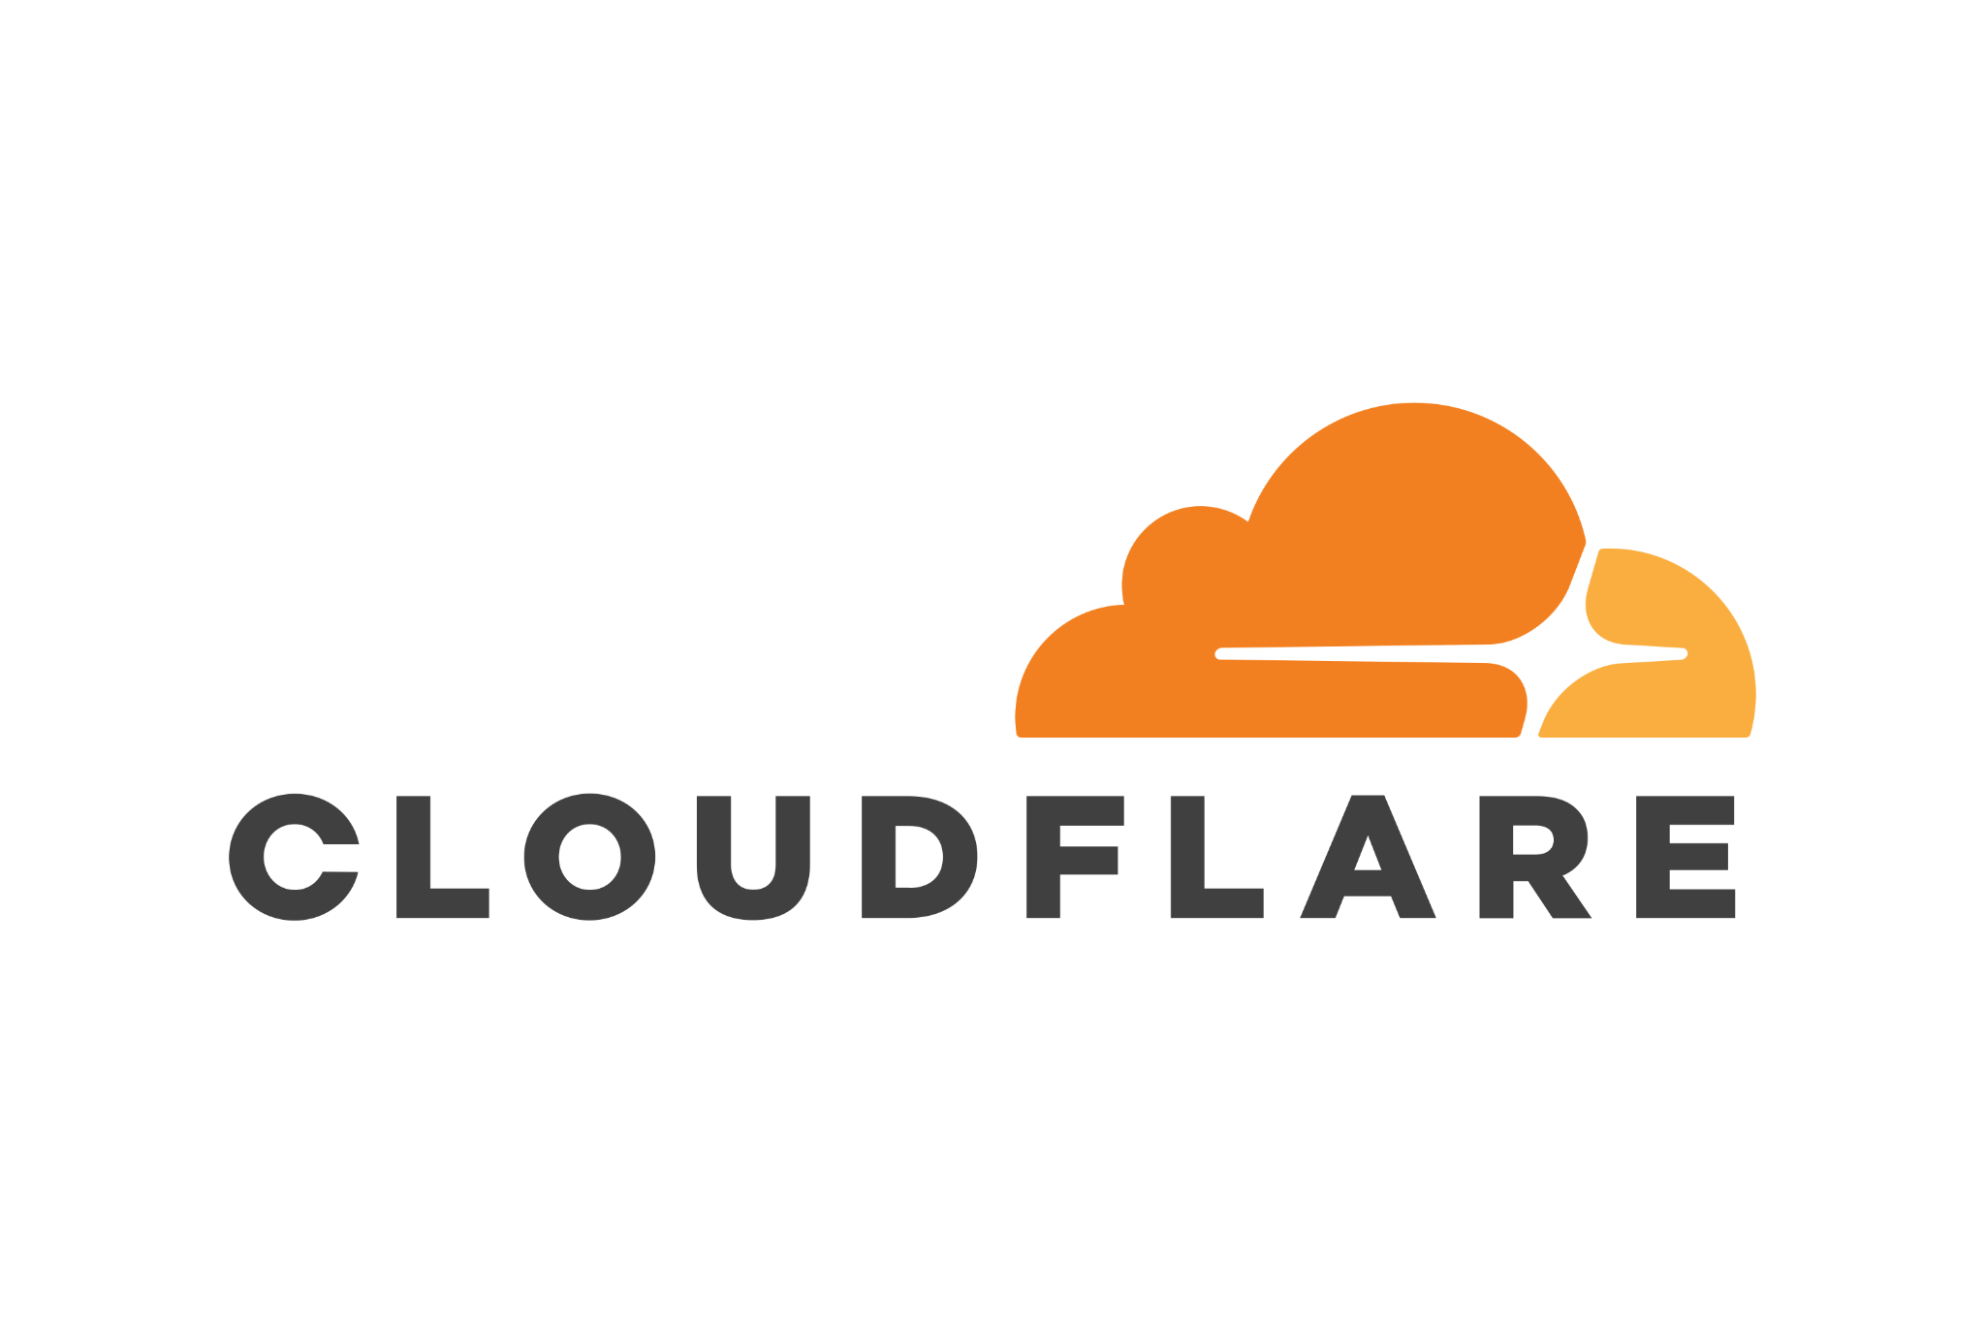  Cloudflare (DNS)  Cloudflare (SSL/TLS + Origin Certificate)  Cloudflare (Proxy + WAF/Firewall tools)  Cloudflare (CDN caching) | Manages the system domain/subdomain and DNS records (A/CNAME/TXT) for deployment and verification, with fast updates and centralized control
HTTPS and secure access |  | Provides HTTPS for users and encrypts traffic to the server (Full/Strict), reducing risks from misconfigured SSL on the origin.
Edge security |  | Adds a security layer in front of the server (e.g., basic filtering, rate limiting, DDoS protection) to reduce direct exposure of the origin.
Performance (optional) |  | Caches static assets to improve load time and reduce load on the origin server during peak access or demos.
RAG-enabled decision support | NotebookLM | Enables the system to retrieve relevant institutional records, policies, and supporting documents first, then generate responses based on those sources. This makes the assistant more appropriate for student status checking, guided summaries, completion rate analysis, and rule-guided next-step prompts. The tool is intended for retrieval-based decision support only and does not perform automated approvals or policy modifications.

